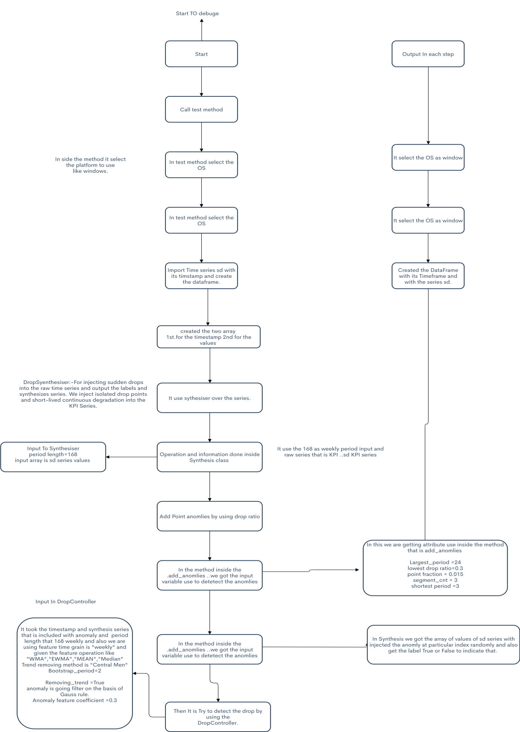

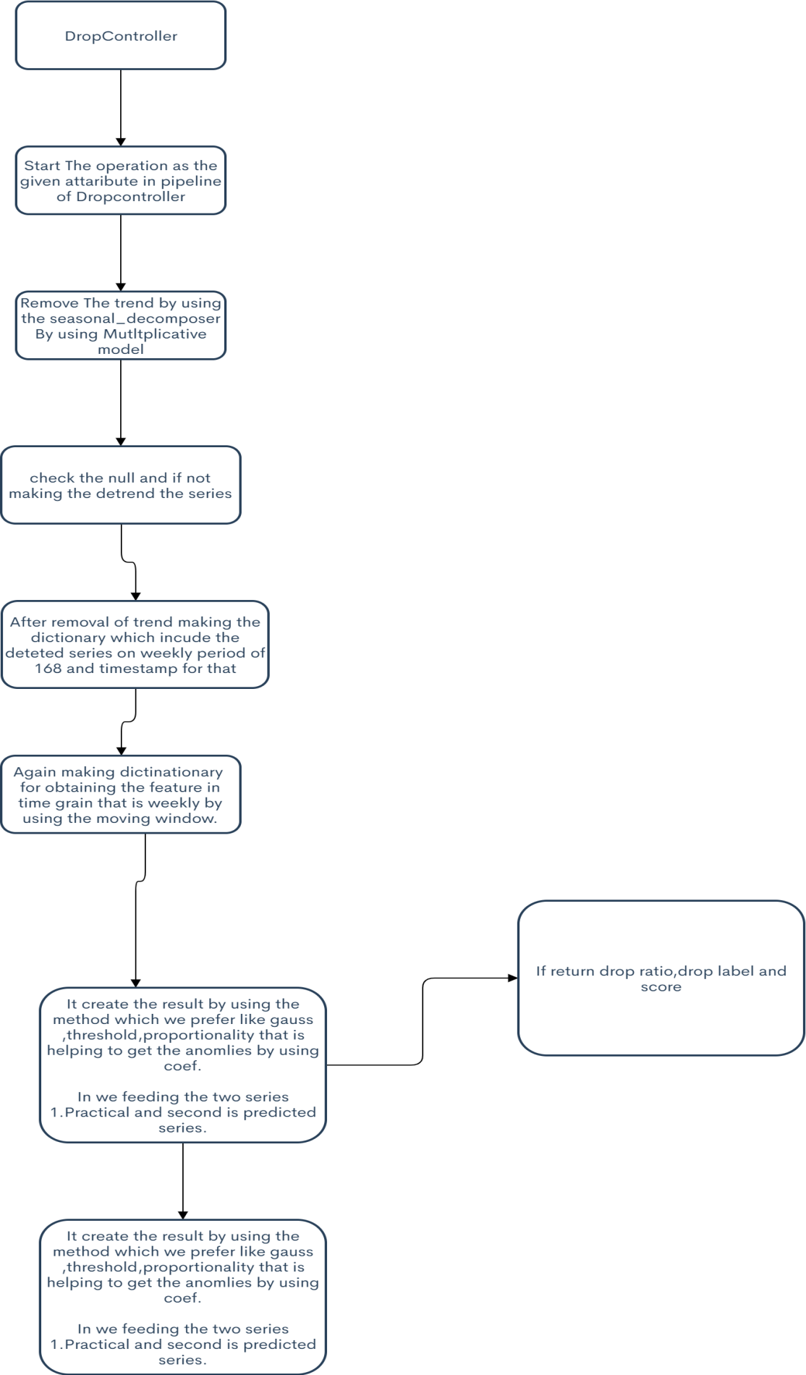

The Both Images I have given is the flow of Example. drop

If Anyone want to see more clearly these Images It can possible,…..

For 1st Image: - <https://www.zenflowchart.com/docs/view/ygqPGELe31EZRb698jZX>

For 2md Image:- <https://www.zenflowchart.com/docs/view/8rVoJX7axk8R3eyv4Ek3>

Complete Flow of All Packages

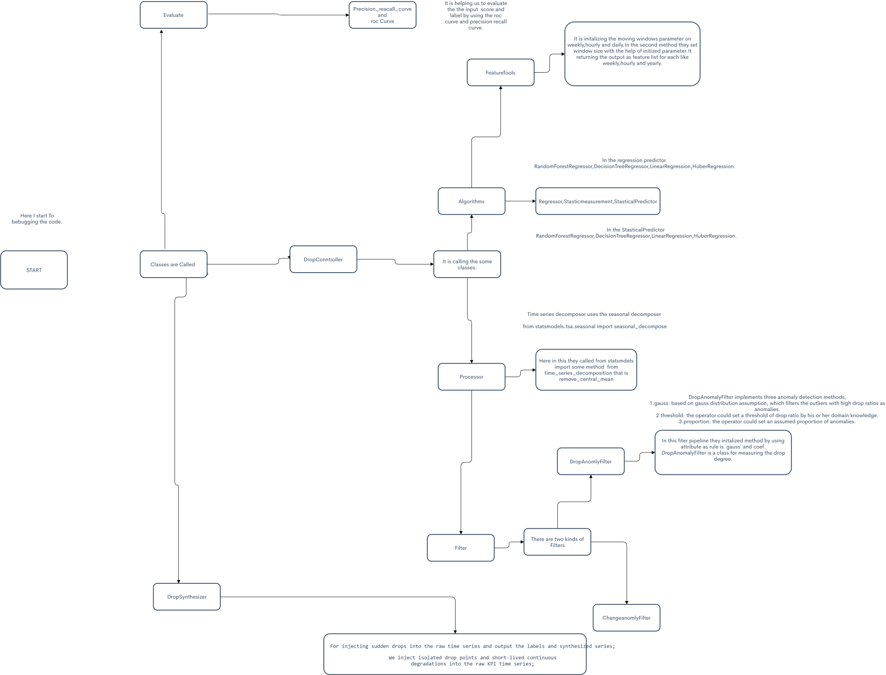

If you want to see these very clearly please make sure to see this link:-

<https://www.zenflowchart.com/docs/view/gW9QqM7e5yV28e2vp5lo>